### ****Targeted Modifications for Point-E Project****

All modifications are located in: point-e/point_e/enhancements/

### ****Enhancements Overview****

1. **New Data Preprocessing Step**
   * **File:** normalizepointcloud.py
   * **Description:** Normalizes 3D points to standardize input data before model processing.
   * **Purpose:** Ensures consistent scaling and positioning of point clouds, enhancing model stability and performance.
2. **Small Output Post-Processing**
   * **File:** bilateralsmoothing.py
   * **Description:** Applies bilateral smoothing to reduce noise in the generated point clouds.
   * **Purpose:** Enhances the visual quality and realism of the 3D output by preserving edges while removing noise.

### ****Integration with Existing Pipeline****

The enhancements are managed through applyenhancements.py  
The function enhance_point_cloud(pc) is invoked just after the line:

pc = sampler.output_to_point_clouds(samples)[0]

in the existing text2pointcloud and imagetopointcloud scripts, ensuring the point cloud is normalized and smoothed before visualization.

**Implementation Details**

1. **Normalizing 3D Points (**normalizepointcloud.py**)**
   * **What Changed:** Added normalization to preprocess 3D point cloud data.
   * **Why:** To standardize the point clouds for consistent input scaling.
   * **Impact:** Improved stability in model performance.
   * **Example:** Point clouds are scaled to fit within a unit sphere.
2. **Bilateral Smoothing (**bilateralsmoothing.py**)**
   * **What Changed:** Implemented bilateral filtering for noise reduction.
   * **Why:** To enhance visual quality by preserving edge features while removing noise.
   * **Impact:** Smoother and more realistic 3D outputs.
   * **Example:** Applied after point cloud generation to refine the model's output.

### ****Results & Metrics****

* Informal observations indicate enhanced stability and improved output realism.

**text2pointcloud Output**

* **Results Prior to Enhancements**

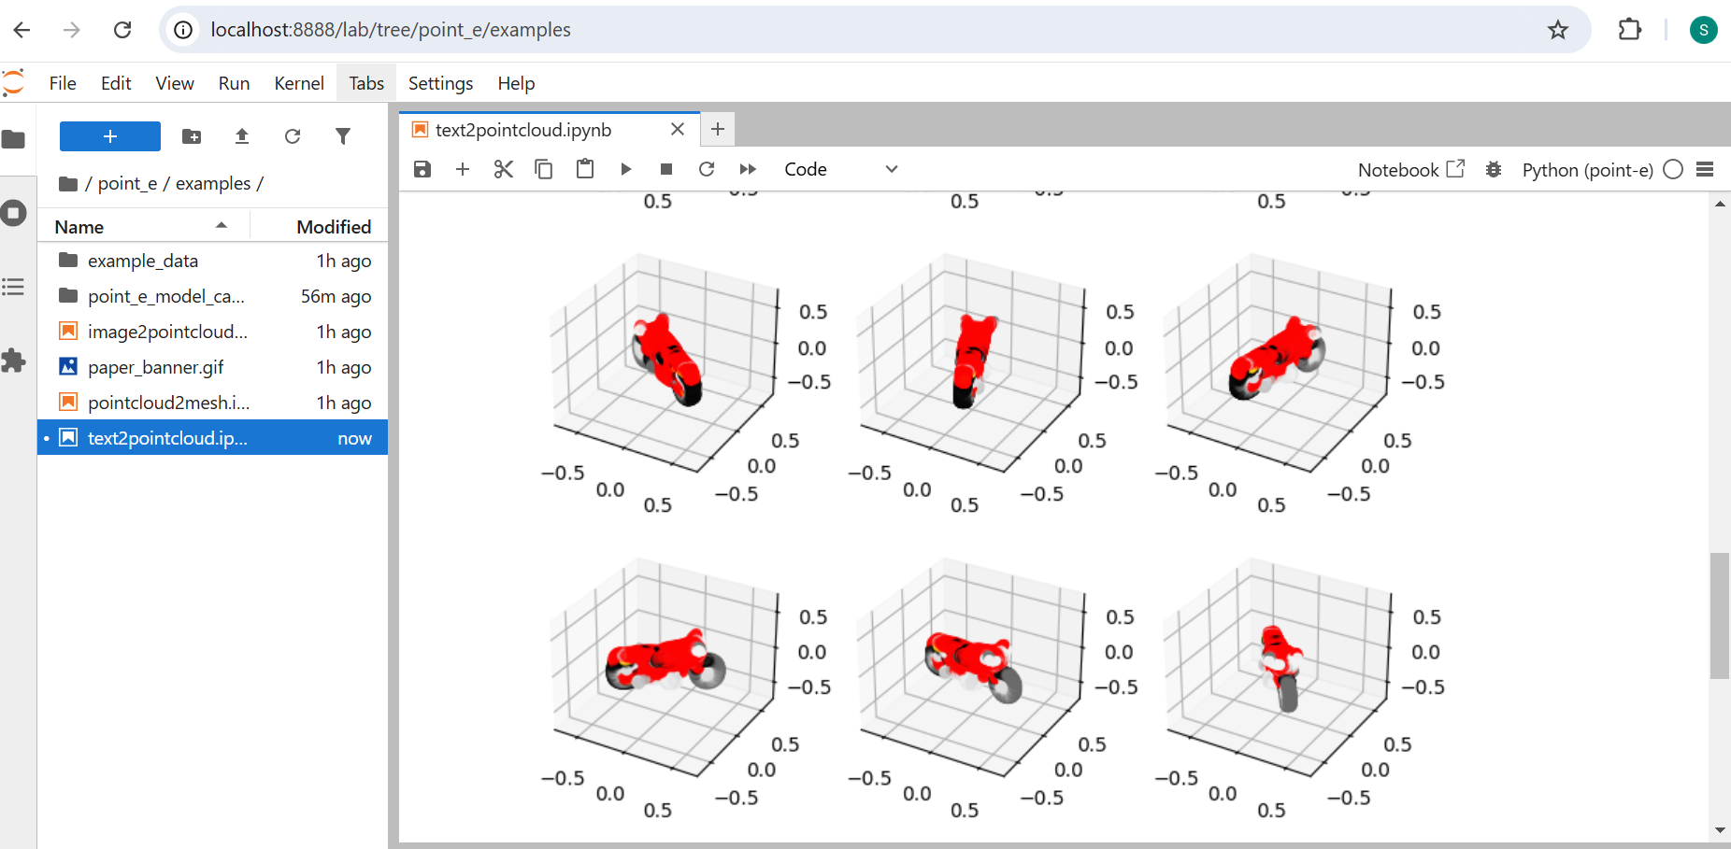

* **Results Following Enhancements**

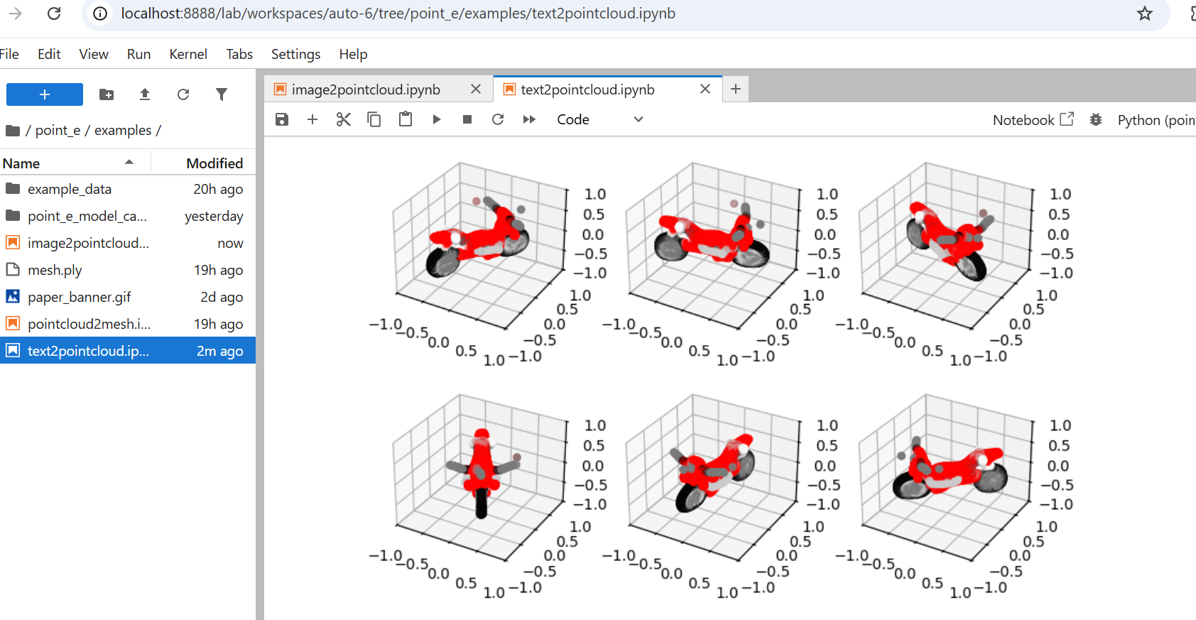

**imagetopointcloud Output**

* **Results Prior to Enhancements**

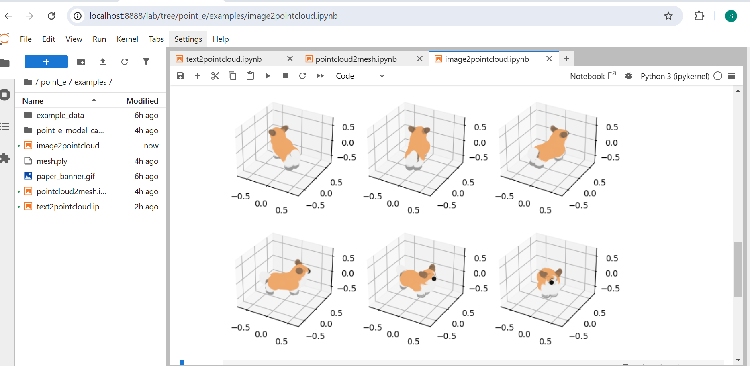

* **Results Following Enhancements**

